Advancing Clinical Decision Support:
Shareable Clinical Decision Support (CDS) Interventions Users Guide

November 18, 2011

Table of Contents

1.0 About this Users Guide 3
2.0 About the Advancing Clinical Decision Support Task 4 project and CDSC KM Portal 3
3.0 Methodology for Developing the CDS Interventions 3
3.1 Selection of Disease Targets and Intervention Types 3
3.2 ACDS XML Artifacts Published on CDSC KMportal 4
3.3 Methodology for Development of the ACDS Interventions 5
4.0 Rendering the Interventions in an XML Schema 6
4.1 History of the XML Schema 6
4.2 For Developers Who Wish to Import the CDS Interventions 8
5.0 Viewing the ACDS Interventions in Human Readable Form 8
5.1 Subject Matter Expert Style Sheet 8
5.2 Knowledge Engineer Style Sheet 8
5.3 Knowledge Engineer – Developer Style Sheet 8
6.0 Navigating an Knowledge Engineer Style Sheet 8
6.1 Overview 8
6.2 Metadata Section 9
6.3 Applicable Scenario Section 10
6.3.1 Alerts and Reminders 10
6.3.2 Documentation Templates 11
6.3.3 Order Sets 12
6.3.4 Value Sets 13
6.3.5 Reference Information or Infobuttons 14
Appendix 1: Glossary 15

1.0 About this Users Guide

This document is provided by the Advancing Clinical Decision Support (ACDS) – Task 4 Team which is supported by the United States government’s Office of the National Coordinator (ONC). It provides a quick reference to navigating and utilizing the Clinical Decision Support (CDS) knowledge interventions that are now available on the Clinical Decision Support Consortium (CDSC) Knowledge Management (KM) Portal.

- More information on the ACDS project can be found here: http://www.rand.org/health/projects/clinical-decision-support.html
- Access to the CDSC KM Portal is via this URL: http://cdsportal.partners.org/
- Access to the CDSC KM Portal Users Guide describing how to navigate and search for CDS interventions can be found here: http://cdsportal.partners.org/UserGuide.doc

- Additional information on the CDSC can be found here: http://www.partners.org/cird/cdsc

2.0 About the Advancing Clinical Decision Support Task 4 project and CDSC KM Portal

The ONC Advancing CDS effort is a project intended to accelerate the effective use of computer-based clinical decision support (CDS) interventions to facilitate evidence-based clinical practice and the meaningful use of health IT. In Task 4 of this effort, a team of CDS and knowledge management experts led by Dr. Tonya Hongsermeier of Partners Healthcare has proposed a functional architecture, governance model, standard XML schemas that could serve as a foundation for interoperable sharing of importable CDS interventions on a national scale. In addition, the team has deployed a first-generation example of a CDS knowledge sharing service. The knowledge sharing service expands upon and leverages the infrastructure already developed for the Clinical Decision Support Consortium (CDSC).

A variety of CDS interventions can be found on the portal as documents or files of common types including, but not limited to:
- Microsoft Office documents, spreadsheets, etc.
- Portable Document Format (PDF) files
- HTML or XML documents
- Simple text documents

The ACDS team has published 21 interventions in a highly structured and encoded XML schema that renders them potentially importable into the content repositories of commercial EHR systems. Style sheets are published that render these artifacts human-readable. In addition, there are 14 additional Recommendation Response artifacts that illustrate how the Partners Healthcare System typically enables users to respond to alerts and reminders.

3.0 Methodology for Developing the CDS Interventions

3.1 Selection of Disease Targets and Intervention Types

The ACDS intervention disease targets and intervention types were selected with the following considerations:
- Aligns with Meaningful Use quality measurement goals and requirements

- Represents one of five commonly used intervention types in electronic health records (EHRs) cited in the HIMSS Clinical Decision Support Workbook by Osheroff et al: http://marketplace.himss.org/acct618b/Default.aspx?tabid=44&action=INVProductDetails&args=507&BookTitle=HIMSS%20Store%20-%20Improving%20Outcomes%20with%20Clinical%20Decision%20Support

  - Reminders and Alerts
  - Documentation Templates
  - Order Sets
  - Info-buttons
  - Relevant Data Display
- Illustrates how an institution with a rich library of clinical decision support (in this case, Partners Healthcare System) might translate their proprietary CDS content, that is actively in production and in use, into a structured, encoded schema and share these interventions on a publicly-accessible knowledge sharing portal
- Leverages available standards for data encoding such as eMeasures value sets, SNOMED, LOINC, RxNorm, ICD9 and the like. Immature standards for representation of patient orders, templated observations, and medication classes limited the number of artifacts that could be transformed for interventions such as documentation templates, order sets, and relevant data display.

The ACDS team evaluated the inventory of content currently in production at Partners Healthcare System and identified artifacts that aligned with quality management targets that were described in the Meaningful Use regulations. The team then identified which artifacts were amenable to translation into a structured schema and encoding with available standard terminologies and value sets. Sharing CDS content is often dependent on the availability of shareable, standard definitions of data, classes and/or diseases such as standard order catalogues, drug classifications and/or problem list value sets. The NQF eMeasures-identified value sets (http://www.qualityforum.org/Projects/e-g/eMeasures/Electronic_Quality_Measures.aspx#t=2&s=&p=&e=1 ) were leveraged to the greatest extent possible.

3.2 ACDS XML Artifacts Published on CDSC KMportal

The following table provides a list of the ACDS interventions now available on the portal. These interventions represent translations of PHS CDS interventions into an XML schema initially developed by the CDSC team and then extended in collaboration with the ACDS team to accommodate a broader set of intervention types. The artifacts were then encoded leveraging standard terminologies such as SNOMED, LOINC, and CPT as well as eMeasure value sets where relevant.

 | ACDS Artifact | CDS Knowledge Types
 | - Annual Blood Pressure Screening Overdue | Alert/Reminder
 | - Chlamydia Screening, Overdue | Alert/Reminder
 | - Diabetes, Lipid Profile Almost Overdue | Alert/Reminder
 | - Diabetes, Lipid Profile Overdue | Alert/Reminder
 | - Diabetes Mellitus, HbA1c Almost Overdue | Alert/Reminder
 | - Diabetes Mellitus, HbA1c Overdue | Alert/Reminder
 | - Diabetes Mellitus, Poorly Controlled, HbA1c Overdue | Alert/Reminder
 | - Diabetes Mellitus, Overdue Eye Exam | Alert/Reminder
 | - Diabetes Mellitus, Overdue Foot Exam | Alert/Reminder
 | - No ADHD on Problem List, on ADHD Meds | Alert/Reminder
 | - No Coronary Artery Disease on Problem List, history of CAD-related procedures | Alert/Reminder
 | - No Diabetes on Problem List, on anti-diabetes meds | Alert/Reminder
 | - Pneumococcal Vaccine due | Alert/Reminder
 | - Undocumented Smoking Status | Alert/Reminder
 | - Smoking Status | Documentation Template
 | - Smoking Cessation, Outpatient | Order Set
 | - Venous Thromboembolism Prophylaxis, Inpatient | Order Set
 | - Obesity Management, Outpatient | Order Set
 | - Medication-Related Patient Education | Infobutton
 | - CDC Recodes for Smoking Status | Value Set
 | - CDC Recodes for Active Smoker | Value Set

3.3 Methodology for Development of the ACDS Interventions

The ACDS team began the translation of Partners Healthcare CDS interventions into structured, encoded XML by leveraging the National Quality Forum (NQF) eMeasures specifications and data codes and the Clinical Decision Support Consortium (CDSC) XML schemas.

For example, if one considers the NQF eMeasure 0575 which evaluates whether or not the HgA1c in adults with Type 1 or Type 2 diabetics is maintained at <8%, this measure has a specification that defines the class of adults with diabetes who had an encounter within the last year and relevant laboratory test results. These definitions refer to a variety of value sets sourced from terminologies such as SNOMED, ICD9, ICD10, CPT, RxNorm and LOINC.

The ACDS team selected decision support rules from the PHS inventory that assist with HgA1c monitoring and problem list hygiene and then crafted a rule set that leveraged the eMeasure value set definitions. The following decision support interventions were defined:

- If last [HgA1c] in the [Type 1 or Type 2 DM] adult is within target range and hasn’t been resulted in 6 months, notify that HgA1c is overdue and recommend HgA1c testing
- If last [HgA1c] in the [Type 1 or Type 2 adult] is within target range and between 5 and 6 months old, notify that HgA1c is almost overdue and recommend HgA1c testing
- If last [HgA1c] in the [Type 1 or Type 2 adult] is above target range and between 3 and 5 months old, notify that HgA1c is above target range and recommend more frequent testing
- If adult is on [Diabetic Medications] and does not have [Type 1 or Type 2 DM] on the problem list, and does not have [Steroid-dependent DM or Polycystic Ovary Disease or Gestational DM] on the problem list, notify caregiver that patient is on diabetic medications and does not have DM on the problem list and recommend the addition

Each of the bracketed elements above defines a clinical state, or condition that must be precisely defined to be implemented in CDS. Thus, when looking at a clinical performance goal such as glycemic control, the development of logic for measurement and the logic for clinical management courses along two parallel paths that primarily overlap in the sharing of value set definitions. The following diagram depicts schematically how the clinical state definitions of the eMeasures and CDS were leveraged to build the above rules statements:

Figure 1. Conceptual relationships between NQF QDM Value sets, eMeasure specifications, and CDS logic specifications

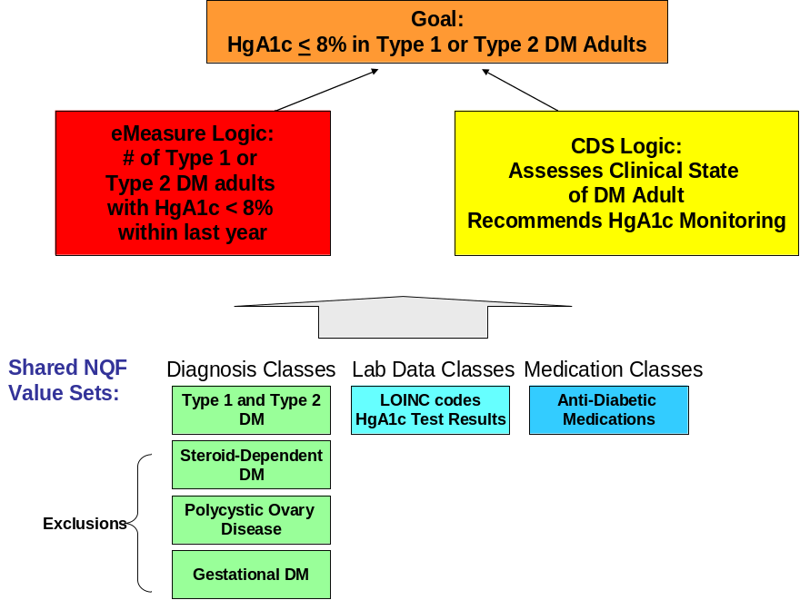

4.0 Rendering the Interventions in an XML Schema

4.1 History of the XML Schema

The ACDS knowledge representation XML schema represents a broadening of the Clinical Decision Support Consortium (CDSC) Level 3 XML that was developed leveraging multiple other standards development efforts including:
- GELLO
- HL7 CDS standards (e.g., Arden Syntax standard and standards for order sets and value sets) and
- HL7 Context-aware Information Retrieval (Infobutton) standard
- HL7/OMG Decision Support Service standards
- ASTM GEM model
- HITSP standards (e.g., HITSP C32 Continuity of Care Document standard).
The Clinical Decision Support Consortium (CDSC http://www.partners.org/cird/cdsc/ ) knowledge model specified four layers of knowledge transformation and encoding that range from natural language free-text knowledge to executable codified knowledge:
- Unstructured (Level 1/L1): any human readable knowledge in any document format.
- Semi-structured (Level 2/L2): at this layer, knowledge is deconstructed and encapsulated as individual recommendations. These knowledge specifications are primarily authored by clinical domain experts. A schema is developed for this layer, but knowledge is not codified.
- Structured (Level 3/L3): this layer defines and specifies the structure and semantics of all the data elements and logic needed to make the knowledge interpretable by computers. The level 3 artifact has the following major characteristics:
  - The primary authors of the knowledge specifications are knowledge engineers
  - The knowledge in this layer is independent of implementation in a particular type of CDS tool or a particular clinical setting, to maximize its ability to be shared
  - UML models and XML schemas are developed for this layer
  - Data elements are codified as necessary
Due to the nature of the L3 structure, this is the level we adopted, with significant extensions and modifications, for representing the CDS intervention artifacts for the ACDS project.
- Executable (Level 4/L4): this layer is dependent on the specific CDS tool and clinical setting. Programmers implement the knowledge into specific clinical systems with local considerations in mind. This knowledge may not be easily sharable.
The ACDS interventions have leveraged the L3 schema which models knowledge contained in a clinical knowledge resource as a collection of recommendations to be made in various clinical contexts. These recommendations can be organized into modules. Each recommendation consists of metadata, an applicable scenario and a clinical advice (action). Certain data elements (e.g., metadata and applicable scenario) are reusable at different levels of this schema (e.g., at the knowledge resource level, module level or recommendation level). The overview of the schema is shown in Figure 2.

Figure 2. Overview of the Schema
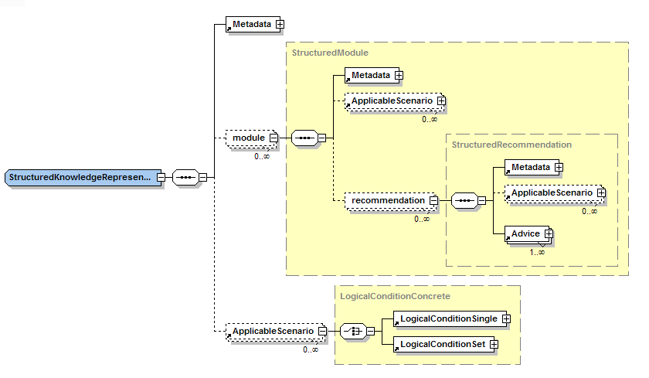

4.2 For Developers Who Wish to Import the CDS Interventions

The CDSC L3 XML Schema (.XSD files), as of November 18, 2011, are accessible on the related resources page: http://cdsportal.partners.org/RelatedResources.aspx?pageId=3

5.0 Viewing the ACDS Interventions in Human Readable Form

There are three kinds of style sheets provided for viewing the XML underlying the ACDS interventions: Subject Matter Expert view, Knowledge Engineer view, and the Developer View. The Knowledge Engineer style sheet is the default style sheet for the CDSC portal. It will automatically display when users click on the artifact file name on the portal. The other two style sheets can be downloaded from the “Related References” page (Figure 3) of the CDSC KM Portal http://cdsportal.partners.org/RelatedResources.aspx?pageId=3 .

Figure 3: Related References Tab:
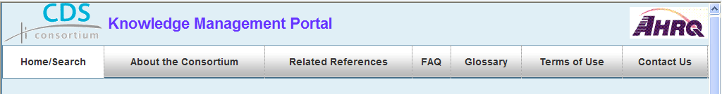

5.1 Subject Matter Expert Style Sheet

The Subject Matter Expert (SME) style sheet is designed to assist a non-technical, clinical resource with the review of the logic in an ACDS intervention and ensure it is consistent with the relevant clinical guideline and the overall CDS intent of the implementing organization. This view strips away much of the metadata and XML tags that might be confusing to a typical non-technical reviewer.

5.2 Knowledge Engineer Style Sheet

The Knowledge Engineer (KE) style sheet is designed to facilitate review and implementation by resources engaged in the authoring and implementation of the CDS interventions. It retains the metadata and the terminology encoding, but does not display any of the tags or structure of the L3 schema.

5.3 Knowledge Engineer – Developer Style Sheet

The Knowledge Engineer-Developer style sheet contains all the elements of the Knowledge Engineer style sheet; however in addition, it includes references to the tags / structure of the L3 schema in order to facilitate review of the content in the context of the schema.

6.0 Navigating an Knowledge Engineer Style Sheet

6.1 Overview

Each intervention contains the following sections:
- Metadata Section
- Title
- Contributor information
- Related Resources
  - Depends on: identifies dependencies on other artifacts such as value sets, necessary to implement a complete intervention
  - Derived from: identifies when an intervention is derivative of another piece of content such as when a Level 3 artifact is derived from another Level 2 or even another Level 3
  - Related Reference: identifies evidence, guidelines or references underlying the intervention such as society-sanctioned guidelines, publications, eRecs from J. Osheroff
- Search Tags
  - Identify key words associated that can facilitate search and retrieval
- Applicable Scenario Section
  - Logical Condition: defines the relevant data inputs that makes the recommendation applicable
  - Recommendation: defines the recommended actions which can take the form of, for example
    - Messages – some of which are patient-oriented
    - Orders
    - Observations to collect
    - Data to display
  - Displayable Resources
    - Reference material that might either be of use to the end-user or as a handout to give to the patient that can be displayed along with the recommendations

6.2 Metadata Section

Figure 4. provides an illustration of the metadata section, in this case of for an HgA1C Overdue reminder. After the title and description, one can see the related resources and metadata.

Figure 4. Navigating the Metadata

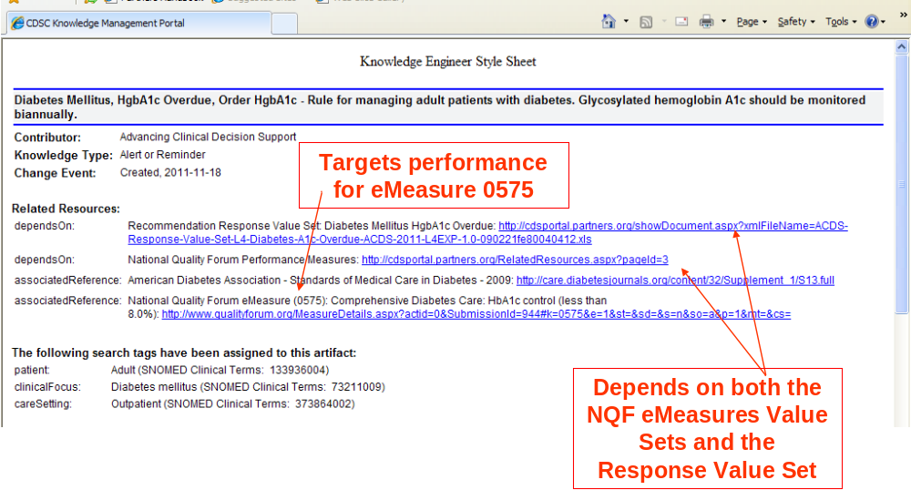

6.3 Applicable Scenario Section

6.3.1 Alerts and Reminders

In Figure 5 below, the logic describing the applicable conditions or triggers are shown for the HgA1c overdue alert. Each condition is accompanied by a pseudo code expression describing how to retrieve the data. In this instance, the eMeasure value sets are referenced for both the definition of Diabetes Mellitus (which is based on lists of SNOMED, ICD9 and ICD10 coded concepts) and HgA1c test results (based on a list of LOINC-coded serum test results). Below the logical condition section is the recommendations section which supports the display of messages and identifies recommended actions.

Figure 5. Navigating the Applicable Scenario section of an Alert or Reminder
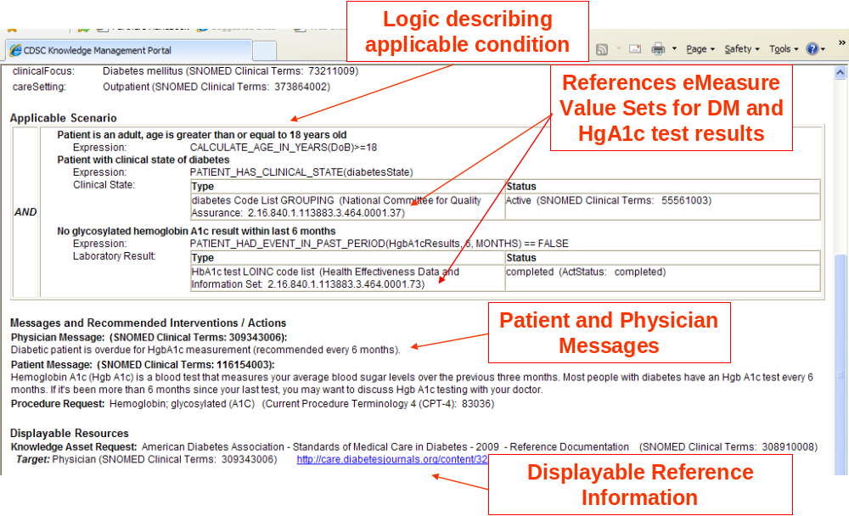

If one returns to Figure 4 above, the “depends on” links point to both the resource for the value set definitions and another resource that identifies how Partners Healthcare System handles recommendation responses for this particular reminder. The “Recommendation Response” is illustrated below in Figure 6. All of the published Alerts and Reminders are associated with a “Recommendation Response Value Set” which is published as a “Level 4” document because it illustrates an implementation specific approach. Standard codes are offered where available, however, the content of the list and attributes such as “snooze duration” are very specific to Partners Healthcare System. Thus, it serves as an illustration of one healthcare system’s approach to implementing a set of reminder responses in an EHR.

Figure 6. Illustration of a Recommendation Response Value Set

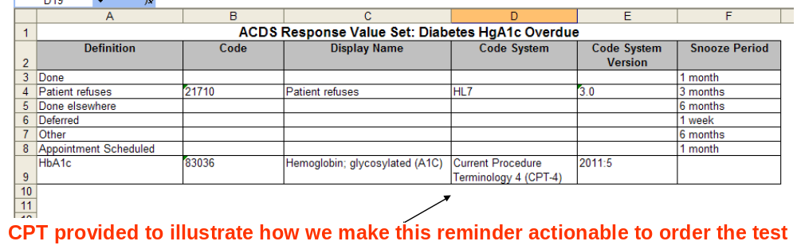

6.3.2 Documentation Templates

Figure 7 below illustrates an applicable scenario section for clinical documentation. Checkboxes are provided in the style sheet for each observation, procedure or encounter request type to illustrate for the knowledge engineer where data could be entered in an EHR documentation workflow. In addition, the schema allows for numerical values or points to be assigned for a given assessment item. This is useful for risk assessment forms such as Falls Risk or Risk for Deep Vein Thrombosis. Section headers are based on the HL7 CDA standard.

Figure 7. Illustration of an Applicable Scenario section for a Documentation Template

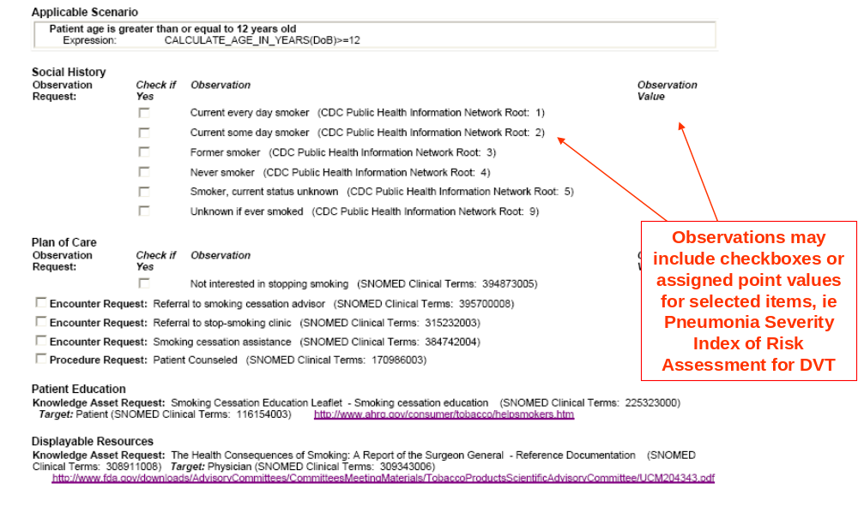

6.3.3 Order Sets
Figure 8 below illustrates an applicable scenario section for an order set. In the case of the Smoking Cessation order set, the logical condition references both a Tobacco User value set referenced in the eMeasures as well as a CDC Recodes value set for smokers. The CDC recodes were specified in the MU requirements for certifying how EHRs enable the capture of smoking status. The ACDS team created a value set of the CDC recodes. One value set is for all smoking status possibilities, it is referenced in a reminder to update the smoking status of a patient. In the order set below for management of smokers, a CDC recodes value set for active smokers was created and published as a dependent resource for this intervention.

Figure 8. Navigating an ACDS Order Set artifact

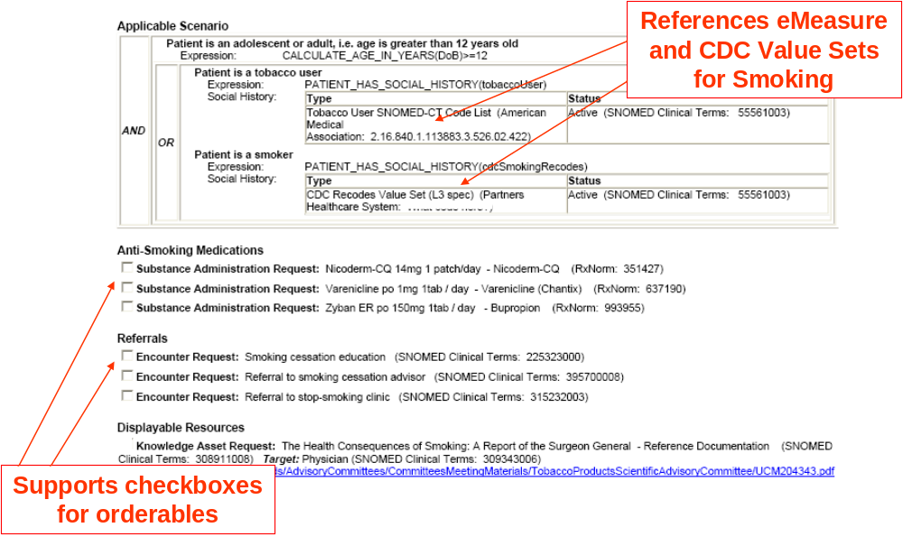

6.3.4 Value Sets

Value Sets are lists of line items that can either be used for the purposes of triggering a logical condition or providing pick lists such as for a recommendation response. Both of these types of Values Sets published by the ACDS project team. The Recommendation Response Value Sets are published as an implementation specific L4 interventions (see Figure 6 above). Figure 9 Illustrates one of the two L3 value sets that were created from the CDC recodes that are represented in an XML schema.

Figure 9. ACDS Value Sets

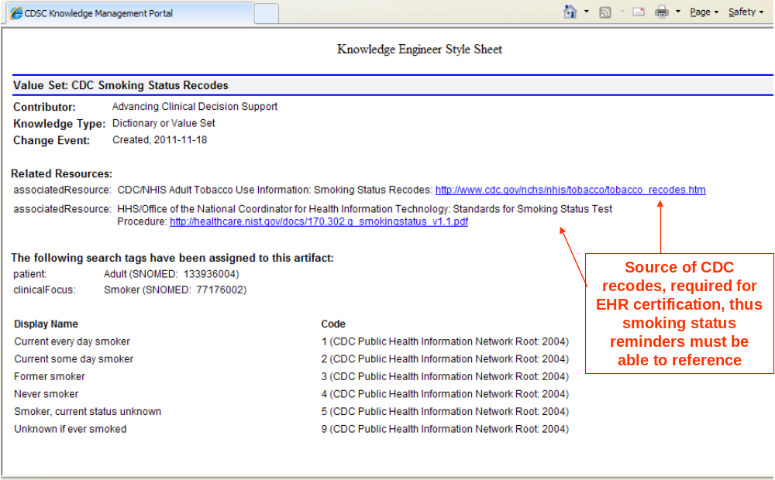

6.3.5 Reference Information or Infobuttons

Infobuttons enable linkage of patient-specific reference information to specific task contexts. Query parameters specify the task context, reference information type, and URL. In the published example, the implementer would be required to insert their institution specific information to access a licensed reference resource.

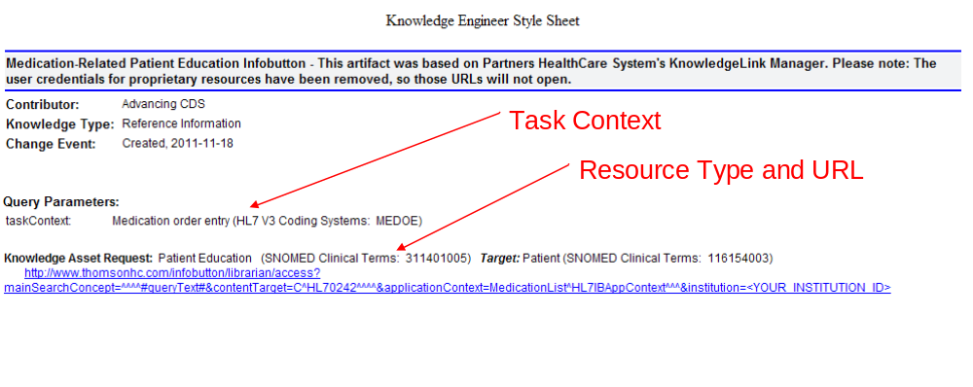

Appendix 1: Glossary

This section describes some of the words and abbreviations used in this document.
Term | Description
ACDS | The ONC funded Advancing Clinical Decision Support project.
AHRQ | Agency for Healthcare Research and Quality: The federal agency sponsoring the Clinical Decision Support Consortium.
CDS | Clinical Decision Support
CDSC | The AHRQ funded Clinical Decision Support Consortium project
CDSC Knowledge Portal | The read only web based portal that stores various CDS artifacts. It is searchable via attributes and meta-data managed in Documentum and published to the CDSC Knowledge Portal.
Content | A body of related data, information, and/or knowledge typically encapsulated within an object such as a document. Sometimes used synonymously with ‘document’.
Documentum | EMC Corporation’s Content Management product used to implement key components of the CDSC Portal.
Document | A familiar type of object used to encapsulate a body of data, information and/or knowledge. Sometimes used synonymously with ‘content’.
ONC | Office of the National Coordinator for Health Information Technology
XML | Extensible Markup Language. A standard for representing data in a highly structured, yet flexible way. Certain CDSC content is authored in XML.
XSL/XSLT | Extensible Style Sheet / XSL Transformation Markup Language. Standards for defining the transformation and display rules associated with associated XML. Certain CDSC XML document display is controlled via XSL/XSLT.

